“Lab” report

# Schematic

# 

# Layout

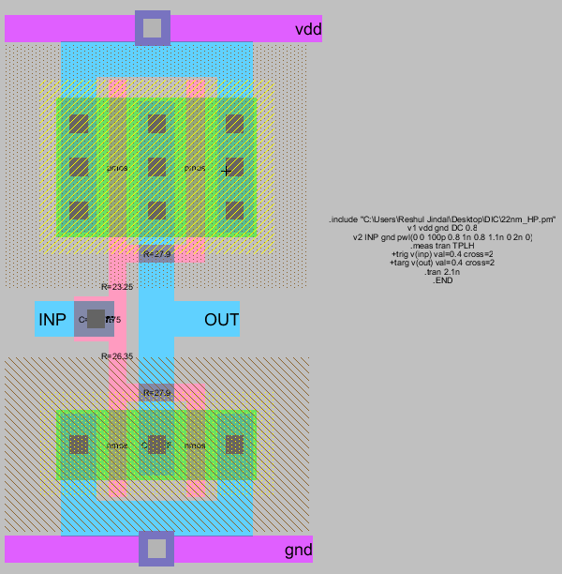

# 

# DRC/LVS report

# 

# Measurement (schematic)

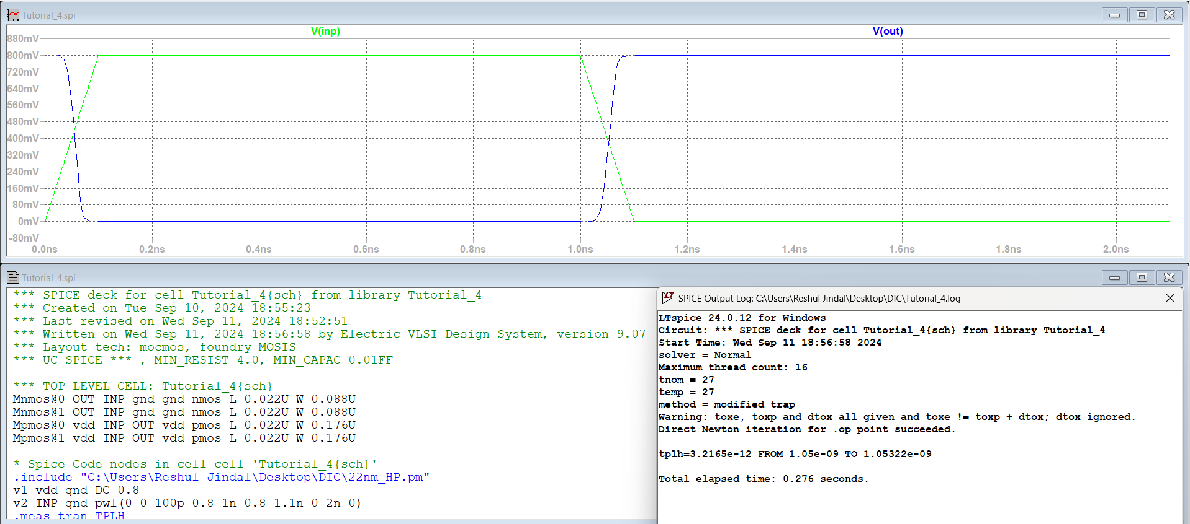

# Measurement (Layout)

